Chapter 4: Admission to Network Facilities Including the VA
Overview:
Patients can be sent out because of a lack of space in the military health system (MHS), lack of eligibility for care, or if they are an involuntary civilian. Active Duty overflow should first be sent to Fort Belvoir Community Hospital or to the District of Columbia Veterans Affairs Hospital (DC-VA) in accordance with the DCVA Sharing Agreement. Residents are exempt from medical licensure pursuant to Maryland Health Occupations Title Sec. 14-302.

Active duty patients should not be sent to outside facilities as long as there is space on either 7W or FBCH 4N. Civilians can and should be sent to civilian facilities if they are 1) involuntary; or 2) do not appear to have the capacity or willingness to continuously stay voluntarily.

A list of Tricare Approved Psychiatric Hospitals for both adults and adolescents can be found at the end of this chapter (last updated June 2018).

Social Work Assistance with Patient Placement at Outside Facilities After Hours

If a patient (either voluntary or involuntary) will need transfer to an outside facility after PCLS signout, please contact the Social Worker On Call as soon as possible to begin facilitating transfer. The on-call social worker can be reached at 703-901-6704. If you are unable to reach the on-call social walker, call the Social Work Department Chief LCDR Sheila Houghton-Antonucci at 412-889-0994. You should check in regularly with the social worker on call to ensure you are aware of the progress that is being made to transfer the patient and to provide them with any patient status updates. Please also keep the ED staff informed of any progress in placing the patient and write regular interim PCLS note updates.

Patients Voluntarily Sent to Other Facilities:
If a patient is voluntary for send-out to another facility, an Application for Voluntary Admission form (DHMH #4) must be completed and faxed to the appropriate facility. This form can be found on the succeeding page.

Note that the standard you must certify on DHMH #4 is that the patient:
- Has a mental disorder
- The disorder is susceptible to care to treatment
- The individual understands the nature of the request for treatment
- The individual is able to give continuous assent to retention by the facility; and
- The individual is able to ask for release if they desire.
While physical and electronic copies are available here; new versions that reflect changes in Maryland law and DHMH regulations are released periodically. You should be able to find the current forms at: https://bha.health.maryland.gov/Pages/Forms.aspx

Patients Involuntarily Sent to Other Facilities:

If a patient requires involuntary admission to another facility, the following forms must be completed and faxed to the appropriate facility. These forms can be found on the succeeding pages:
- Application for Involuntary Admission form (DHMH #34)
- Certificate to Accompany Application for Involuntary Admission form (DHMH #2)-At least two of these forms are required and may be completed by either two physicians, one physician and one psychologist or one physician and one psychiatric nurse practitioner. This form certifies:
- Presence of a Mental Disorder
- Need for inpatient care
- Severity presents a danger to the life or safety of the individual or of others
- Patient is unwilling or unable to be admitted voluntarily, and
- No less restrictive intervention is available
- Report as to Certification of Commitment form (DHMH #2A)

Involuntary patients can only be sent to certain hospitals within the state of Maryland and the involuntary nature of the admission should be stated when you first make contact with a prospective facility. Some facilities that take involuntary patients may ultimately tell you that they do not have any “involuntary beds.”

See also: “Playbook” for Involuntary Psychiatric Patients in the Emergency Room document in this chapter

Process for Sending Patients Out:
Patients being transferred to outside hospitals should receive work-ups equal to those who would otherwise be admitted to 7W or 4N. Prospective receiving hospitals will ask for documentation and notes to ensure medical clearance – just as PODs should request such a work-up from transferring providers. This information (including lab values) will often be required before the patient is accepted. An efficient approach would be for a POD called to the ED to see the patient to complete rating scales and appropriate DHMH forms, staff the tentative plan with the Staff On Call, ensure labs and imaging needed is ordered, enlist the help of the Social Worker on call to contact multiple facilities to inquire about space and record fax information, complete one’s note, send it to those facilities, then wait to hear back. It is wise to take time calling a few facilities initially as bed availability can change while waiting for labs to return or finishing the note. A significant limiting factor is that outside facilities often use middlemen (nurses/social workers) so the order in which your referral is reviewed is beyond your control.

Once accepted, the POD should write down the accepting providers name and phone number; a number for nursing to call report; and the address including building/unit numbers. The PODs should inform both the ED and patient of updates regularly. The most failsafe approach would be to complete the Ambulance Transfer Request and submit it to the CDO desk and to the ED. The Ambulance Transfer Request will require the name of the accepting provider, address, unit, and number for report. The POD should then place the original documents (notes, ambulance transfer requests, and applications for voluntary admission) in the patient’s hard chart; but also maintain their own copies to pass on to the night-float or day providers. The ED may accept responsibility for completing the Ambulance Transfer Request; however the POD should ensure that it is clear to all services involved who will do this work. This avoids the likelihood of patient’s languishing in the ED – which can lead to conflict with the ED and/or daytime consult team.

Your finalized note – along with the facility the patient is being sent to should be entered into both Essentris and AHLTA.

Often civilian facilities do not provide comprehensive discharge summaries. By placing your note into AHLTA, you will be of great help to the providers who receive this patient after discharge. If you completed your note in Word, then you can copy and paste the same note into the “Add Note” section of AHLTA as well as the text box for your note in Essentris. You should put it in AHLTA because most out-patient providers do not have access to Essentris. You should put it in Essentris because it is still part of patient’s emergency room record.
- TIP: Bring a copy of the voluntary application with you to see the patient, have patient sign it and leave the top blank, include the signed application with blank facility name in the packet you send hospitals
- TIP: You should include the “Demographics” page from AHLTA (screen capture with “Prnt Screen” and paste into word then print it out and include with fax. This serves as proof of insurance for the receiving facility)
- TIP: On call SW should be contacted and they will assist with the placement process (see above).
Inpatient Network Admission Consult Orders:
Inpatient Network Admission Consult Orders are necessary any time you send a patient for an inpatient stay at a non-military facility. This goes for adults and children sent out from the ED, as well as for patients sent from 7W to outside facilities (e.g.; substance rehabilitation, residential PTSD facilities like Freedom Care), and for Veterans Administration Hospitals. This is how Tricare knows the indication for paying the non-DoD entity.

When sending a patient to a private inpatient facility, you must place a consult order. This can be done as part of your AHLTA note – see the “A/P” steps of making an AHLTA note or in CHCS.

How to Enter an Network Inpatient Admission Consult into your AHLTA Note:

Make sure the consult is for: INPATIENT ADMISSION NET BE.

AHLTA Consult order step by step instructions:
- Select Patient
- Open encounter
- Proceed to A/P section
- Select order consult tab
- Top box enter: Behavioral Health MTF BE.
- Clinic name will automatically default to RM BEH HLTH BE which is the one box.
- Complete consult with the following information: Name of facility, address, telephone number accepting physician, tax ID#, and reason for referral.
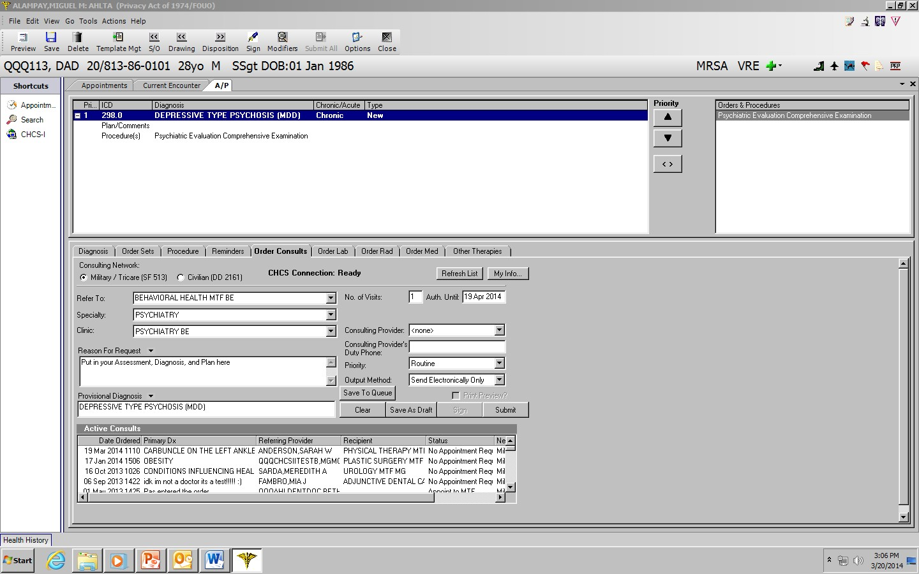

CHCS Consult order step by step instructions:

- OREx2
- Select Patient Name:(enter patient demographics)
- Requesting Location: enter Psychiatry Consult Liaison BE or Inpatient Psychiatry
- HCP Pager Number: 202-668-1014
- Action: New Order
- Order type: Con
- Consult Procedure: fill in required fields
Make sure to include Name of facility, address, telephone number accepting physician, tax ID#, and reason for re

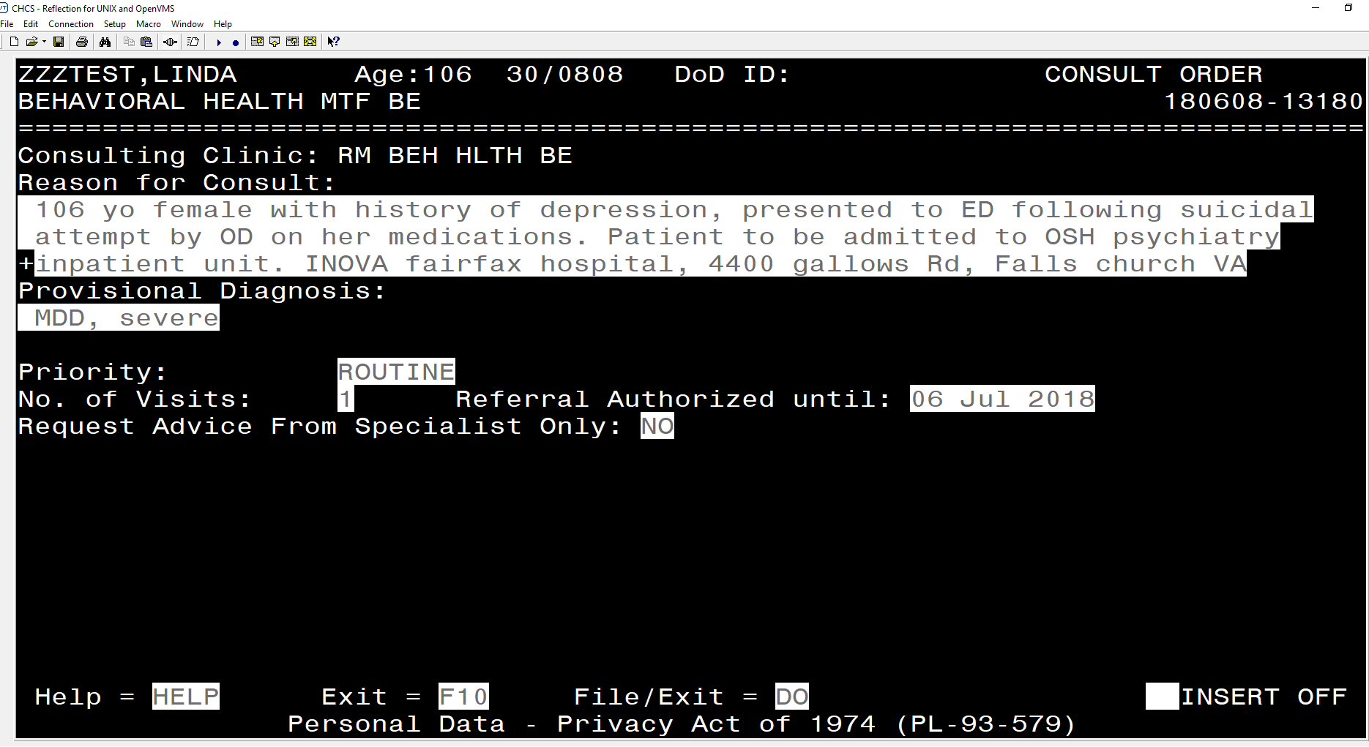

DC VA Inpatient Admission (we are in the process of developing this system) The sequence of steps at the top worked in FEB 2019. The sequence of steps at the bottom is a work in progress from the VA:

In the event there is no space for active duty patients, WRNMMC and FBCH have a bed-sharing agreement with the DC Veterans Affairs Medical Center. To qualify, the Active Duty Service Member cannot be enrolled in WTB and must be voluntary.

-Provide patient information, Chain of Command information, and the VA Referral Form (complete just the top 2 portions).
-Complete AHLTA note with consults: Inpatient Admission Net Be & Case Management.

To Reach DCVA Psychiatry for transfer
From 0800-0000 call the main automated number: 202-745-8000 , Ext. 57728 for ED Social Work

From 0000-0800:
-First dial: DCVA automated operator (202) 745-8000, then try these extensions:
-Ext for AOD: 58236
-Ext for ED: 57130, 57058
-Another ext: 8360

Once you reach a person on one of the above numbers, ask them to page the DCVA Psychiatry Resident on-call pager: 202-516-3526 and give the psychiatry resident on call the POD phone number and ask them to call you back.

ADMISSION OF MILITARY MEMBERS FOR
DC VA INPATIENT BEHAVIORAL HEALTH CARE

Ensure patient meets criteria for VA admission: NOT enrolled in Wounded Ill & Injured program, Active duty, and Voluntary status.

Contact DC VA for accepting provider:
0800-2400:
ED Social Worker: 202-745-8000 EXT 7728
Dr. Aquanette Brown – 302-507-0634 (back-up number)
Dr. Tzvetelina Dimitrova – 202-740-8452 (back-up number)
Fax - 202-745-2465
2400-0800:
Psychiatry Officer of the Day - 202-516-3526
If there is no response within 10 minutes, please contact:
Dr. John Cosgrove at 410-707-9789
Dr. Dominique Neptune at 703-851-2835

The ED Social Worker will inform DOD of bed availability on the acute inpatient unit at the DC VAMC. The ED Social Worker will need to have the patient’s full name, full social security number, and date of birth in order to enroll the patient in the VA system. The ED SW will ask for the MTF provider’s contact information so that a verbal hand-off can take place. The ED SW will provide that information to the Psychiatry Officer of the Day (POD) at the VA who will then contact the MTF provider for the clinicals.

Complete only the top two portions of the VA Referral Form 10-0454 (MTF contact information and the Patient Personal information) at the link below which is REQUIRED for any patient that has not been previously admitted to the DC VA for care:
www.va.gov/vaforms/medical/pdf/vha-10-0454-fill.pdf

Obtain name and phone contact for patient’s Commanding Officer.

Complete AHLTA encounter with all indicated behavioral health and medical information. Add the following CONSULTS to the encounter:
Inpatient Admission NET XX (where XX is 2-letter CHCS facility abbreviation) – include
1) Patient is going to DC VA, 2) Start date of care, 3) Attending physician, 4) Requirement for Inpatient Behavioral Health Care.
Case Management XX (where XX is 2-letter CHCS facility abbreviation) with “ASAP” Priority (instead of default “Routine” Priority) and include: 1) Patient is going to DC VA, 2) Attending physician, 3) Request that Case Management contact attending physician at 202-745-8000 x7303 to review case and assist with discharge planning, 4) Command contact info.

Fax the VA Form 10-0454 (if indicated), Command contact information, AHLTA encounter (including all relevant labs) to the VA Psychiatry Ward at 202-745-2465. When speaking with the POD, confirm the fax has been received and review documentation as needed PRIOR TO TRANSPORTING THE PATIENT.

Arrange ambulance transport of the patient. Ensure transport team is instructed to take the patient to the DC VA ED only as a point of entry to the hospital (NOT for re-evaluation). The transport team should notify DC VA ED staff that the patient has been accepted to the Psychiatry Ward and request that Psychiatry staff come down to escort the transport team and patient to the ward.

