Chapter 1: Introduction to the POD Role
Overview:
The role of Psychiatrist on Duty (POD) is typically assigned to second-year psychiatry residents as part of short- float, night-float, or weekend coverage. The POD serves as the in-house subject expert for all things psychiatry. This includes both adult and adolescent consults on the wards and the emergency room. The POD is supported by a weekly rotating staff member on call – credentialed psychiatrist – whom the POD should staff all decisions with unless instructed otherwise by the staff on call. When assigned an intern and or medical students (e.g. during weekends and short float) the POD can delegate responsibilities but remains responsible for the supervision of the responsibilities delegated.

Contact Information:
POD/PCLS Pager: (202) 668-1014 | 7W Resident Room Fax: (301)319-2180 | PAD: 295-2126
7W Duty Cellphone: (301) 366-2968 | Call Room GME-4: (301) 400-2451 | Pharmacy: 295-2121
7 West Front Desk: (301) 295-4095 | Call Room GME-5: (301) 400-2452 | FBCH Adult: 571-231-4651
LCDR Williams Cell: (706) 464-1913 | Skytel pagers: 1-866-295-4913 | FBCH Adolescent: 571-231-
7E Front Desk: (301) 295-4600 | ER: (301)295-4810 | 7233

Schedule:
The typical times for POD coverage are as follows:

Work Week
Short Float: 1500 – 2000 (M-T-Th)
Wednesday: 1700-2000 (after didactics/grand rounds) Night Float: 2000 – 0730 (Sun – Thursday)

Weekend
Friday: 1500-0800 (next day)
Sat/Holidays: 0800-0800 hours (24 hr shift) Sunday/Holiday before week re-starts: 0800-2000

Sign-Out:
The short-float POD is responsible for obtaining sign-out from three main services: Psychiatry Consult and Liaison Service (PCLS) at 1500 in the PCLS Conference Room (Room 7037, code 9307*), Inpatient Psychiatry (7W) at 1530 in the 7W Conference Room (Room 7004, code 7004*), and the TBI/Neuropsychiatry Service (7E) at a time and location mutually agreed upon by the POD and 7E 4th year resident or 7E attending (typically after completing PCLS sign-out).

The night float POD begins his or her duties at 2000 and should arrive in time to receive sign-out no later than that time. The night float POD should take his or her time to be familiar with the status of the services he or she is inheriting from the short-float. The short-float POD should pass on any reports or warnings about any outside

patients as well as any paper relevant to unfinished work. Each class of PGY-2s should develop their own norms as to what time is appropriate for the short-float to stop working on new consults and focus on preparing for sign-out at 2000. Although it may be appropriate to not begin working on a new consult close to sign-out a short-float provider should continue to take consults until sign-out (along with contact information) and turn those consults over to the night float. Once given the pager, PODs should check to see if any pages appear unanswered and inquire as to why they had not.

Morning Turn Over:
Turnover on weekends occurs in the 7W Conference Room (Room 7004) and is attended by the on-coming charge nurse, night float POD, weekend/holiday intern and POD, and the Staff on Call. Rotating medical students may also attend based on the schedule set by the rotation coordinator.

Weekday turnover for PCLS typically occurs at 0700 in the PCLS Resident Work Room (Room 7034, code 4217*) during which time the POD will provide sign-out and hand-off of the pager. All new PCLS floor consults and ED evaluations should be added to the CCIR. New PCLS consults should also be added to the PCLS sign out and new admissions to the 7W sign-out. The sign-out list should also be updated with any follow-up tasks for the PCLS service.

The POD is responsible for updating the Commander’s Critical Information Requirements (CCIR) and e-mailing this document to the appropriate staff members every week day morning (M-F) by 0715. The CCIR conference call occurs every morning promptly at 0715. The POD should be prepared to discuss all patients. This includes work done by other residents in the interim (short float and weekend PODs) and provides strong incentive for each class to agree on the best practices on ensuring the documentation (e.g. notes, H&Ps, rating scales, etc.) is passed along through the various shift changes. Please see go by CCIR ppt in the Chapter 1 folder for further details and instructions for the CCIR as this process is constantly evolving.

Weekday turnover for Inpatient Psychiatry begins promptly at 0730 in the 7W conference room. The POD is responsible for briefly presenting any new patients that have been admitted since the primary team signed off. If other residents present during the morning turnover were involved in the evaluation of the patient; then the POD may delegate the presentation of those patients to those residents.

Turnover to 7E can be done at a mutually agreed upon time by the POD and the 7E resident or 7E attending.

Call Room:
The call rooms are located in Building 10, 7th floor. GME call rooms 4 & 5 are designated to the intern and resident respectively. Trainees are responsible for keeping these rooms clean and in order. Clean linens are found in room 7064. Used linens are removed to room 7122W.

Telephone Consults:
Occasionally phone calls from outpatients or from the CDO desk get routed to you. Typically these are simple medication refills for urgent reasons. If the medications are questionable, or if the clinical situation appears

complex, have a low threshold to refer the patient to the ER for a comprehensive evaluation. Phone encounters are documented in AHLTA as T-cons.

When responding to a telephone consult from a patient expressing suicidality, local instruction (WRNMMC-AI 6490.01) outlines the official course of action:
- The initial goals are to keep the caller on the line and to obtain the caller's name and other identifying information such as date of birth, last four digits of the social security number of the eligible beneficiary, telephone number, and current location. It is also important to be sympathetic, show concern, stay calm, and to listen.
- If the caller is judged to be imminently dangerous (i.e., has threatened to kill himself/ herself, described the plan, and has the means available to him/her), the staff member needs to get the assistance of another staff member to contact local law enforcement regarding the situation. Law enforcement will then respond to the scene. All efforts should be made to keep the caller on the line until law enforcement arrives.
- If the caller is not imminently dangerous, he or she should be directed to go with a family member, friend or by calling 911 to the nearest ED to obtain a full behavioral health evaluation.
- If contact with the caller is lost, WRNMMC security should be notified for calls originating on base, and the appropriate local law enforcement agency contacted for all other individuals.

Break-In Call:
Toward the end of Intern year, residents undergo a period of break-in call. These are dedicated shifts where the intern takes on the functions of the POD. The regularly assigned POD will assume a supportive role and assist as needed by the intern undergoing break-in call. The assigned POD remains responsible for POD functions performed by the intern undergoing break-in call. Break-in call shifts are for the entire duration of a shift during short-float and for the entire duty day if on the weekend – as interns cannot work the entire 24-shift. The staff on call should be informed at the beginning of the shift that break-in call is being done; and the assigned POD should ensure that calls to the Staff on call (for non-emergent reasons) are rehearsed. Break-in call is an important teaching opportunity for PODs and learning experience for interns who will soon be independent PODs. PGY-2s who transfer into the program will undergo break-in call during the initial part of the year.

Staff Psychiatrist on Call (SOC):
Staff are on call for one week at a time (Tuesday to Monday). The staff must ensure their pager, mobile, and home phone numbers are on the 7W sign-out sheet and on the white board of the 7W Conference Room 7004. If staff are not available at checkout rounds, they should contact the POD by 1700. Staff are available at any time during the call shift and residents should not hesitate to contact their staff. If there is a problem with staff availability or supervision, the resident on call should call the backup SOC and if still no response call the Chief of Inpatient Psychiatric Services.

On weekends and holidays, SOC must cosign the History and Physical Exam and write a staff note on all new admissions within 24 hours of admission. Staff admission notes should have a history of present illness, notation of medical illnesses, current medications, acknowledgement of pain issues, mental status exam, DSM-5 diagnosis, and a treatment plan. Staff should review treatment plans and ongoing clinical issues with all current inpatients during morning report.

The POD must discuss all consults and any other clinical questions that may arise during the call shift with the SOC. After residents have rounded on all inpatients, they will call the staff on call with any updates or changes to treatment. Residents who document outpatient/ER consults should flag the note as needing the co-signature of their staff on call. Staff are required to cosign resident documentation within 72 hours.

The following clinical situations must be discussed with the SOC:

- New Admissions (SOC dependent)
- Restraint Use
- Involuntary Admissions
- ED send outs and discharges and AMA discharges

PCLS Consults:

- Transfers to another unit
- Inpatient Consults
- OIF/OEF Referrals to WRNMMC – if needed to be seen over weekend – otherwise just add to the PCLS sign out to be seen during weekdays

The POD holds the PCLS pager afterhours. All pages should be returned as soon as possible. PODs should obtain:
- Patients identifying information
- Location of the patient and acuity of the consult (whether the team feels the patient needs to be seen during the PODs shift or the next day)
- The name of requesting provider and contact information.
- The specific question the consulting providers would like answered or addressed
- The POD can elect to turn over the consult to the day team if clinically acceptable (e.g. no immediate need and nature of consult is such that the patient would do better with a consistent day-time provider) based on competing responsibilities.
All consults whether seen by the POD or to be deferred to follow-on providers should be documented on the CCIR and turned over to the next shift. All cases should be discussed with SOC unless instructed otherwise.

POD Documentation Overview:
 | Essentris H&P | Essentris PCLS  Note | AHLTA  Note | Call Attending? | Medication Reconciliation | Add to Sign out
7W Admit from ER | Yes |  |  | Maybe (depends on SOC) | Yes | 7W/  CCIR
Discharge Home  from ER |  | Yes | Yes | Yes |  | CCIR
ER Transfer Out |  | Yes | Yes | Yes |  | CCIR
ER PCLS Consult and Pt admitted to  Medicine |  | Yes | Yes | Yes |  | CCIR
Transfer from Medical Ward | Use ‘Psych Tx Plan’ as  transfer note |  |  | Yes |  | 7W and  CCIR
Medevac Direct Admit | Yes |  |  | Yes | Yes | 7W
Direct Admit from outside ER or  Inpatient Unit | Yes |  |  | Maybe (depends on SOC) | Yes | 7W
Room Over Night (RON) | Abbreviated Medical  Record |  |  | If questions | Yes | 7W
New PCLS Consult |  | Yes |  | Yes |  | CCIR
Paged for already followed PCLS patient |  | Yes |  | if changes to plan, new PRNs, or  restraints |  | CCIR
Phone call or page  from patient |  |  | T-Con | Yes |  | CCIR

Sample Break-In Call POD Competency List:

POD Competency Checklist for
Date:

Please review the following tasks and ensure you are comfortable completing each of them.

Receive sign-out from all services. Verify bed count and JTF algorithm. Obtain staff contact info.

Locate and familiarize yourself with physical and digital POD binder/ S-drive

ER evaluation to include:
Review medical chart, conduct full psych H & P; obtain collateral information (command, spouse, family, friends), staff case with SOC
Interface with ER providers and/or Command regarding assessment and plan
Relevant Essentris/AHLTA notes with complete A/P and Dispo tabs, i.e. 90792 and consult requests
Email outpatient providers regarding patient encounter and dispo

ER send-out to include:
Find facility, fax docs, once accepted obtain dispo info, ER interface
State of MD paperwork for involuntary admission
DC VA admission

7E coverage to include daily note on weekend/holiday

Med/Surg consult

Conduct command-directed evaluation and complete necessary paperwork for such evaluations.

Demonstrate ability to handle potential psychiatric emergencies while on call (neuropsychiatric syndromes, withdrawal/toxicity, agitation, take-downs

Telephone consult. If a T-con does not occur, the senior resident should show rising POD how to complete a T-con.

How to Make an AHLTA Note:
Step 1: Find your Patient in AHLTA and Make a “New Appointment”
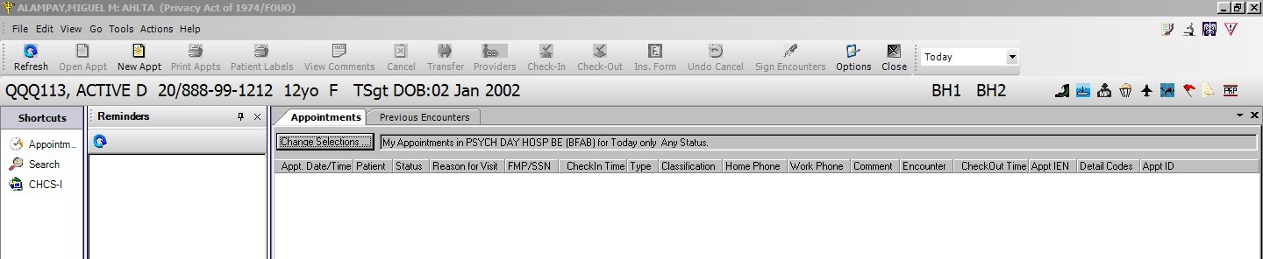
Step 2: Under “Assigned Clinic” click the drop down and select “Psychiatry Consult Liaison Bethesda” If this does not come up, contact your chief resident. Under “Appointment Type” there will be an option for “Acute Appointment”, click that and put in a reason for this appointment. An appointment will show up under your “Appointments” tab. Double-click on that appointment which should appear under your appointments tab; or this screen will open automatically.
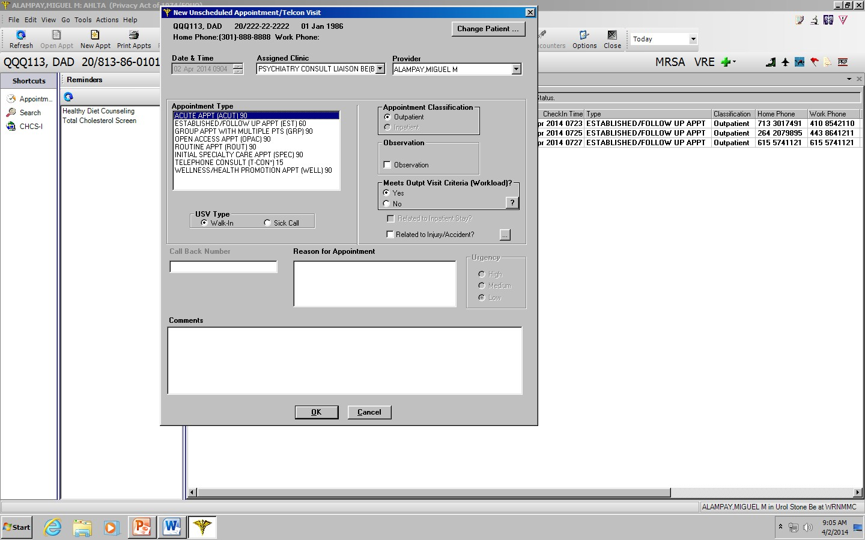

Step 3: The most common means of putting in a note is to compose it in Microsoft Word then Copy and Paste it in the “Add Note” text field.
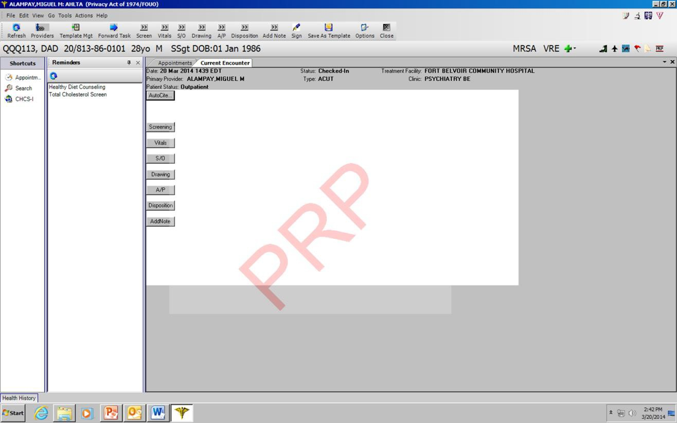

Step 4: This is where you will paste the note. You have around 518kb max that will fit into this.
If you want to add pictures (e.g. CSSRS or Behavioral Rating scales) they will need to be in JPEG format, you can convert PDFs into JPEGs through Adobe Acrobat (on certain computers).
  - First Paste your note and you will be able to fit one or two JPEGs (you do this by clicking “Load File” and
searching for the image you want to add.
  - You then click “Note Complete”
  - To add more pictures/documents, click “Add Note” again; then “New Note”; then “Load File” to add the
additional documents.

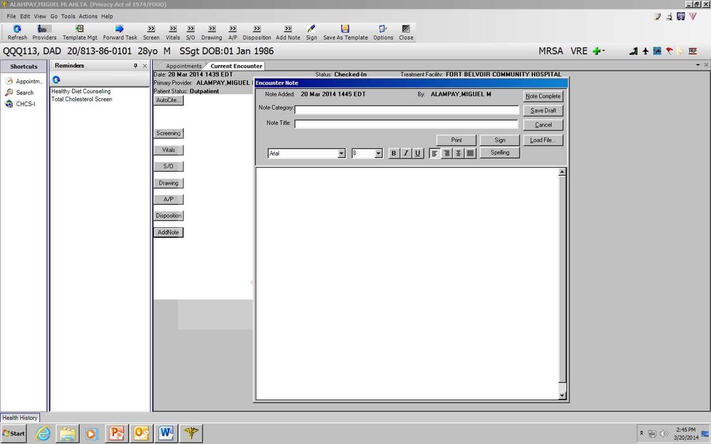

Step 5: In the picture below you see “This is Note 1”; I then clicked “Add Note” again and this screen popped up
- This is where you click “New Note” (red circle) to insert more information (because you were limited by the 518KB maximum for the first note and have more to add).
- If you wanted to edit your note then you would have clicked “Edit Note” (blue circle)

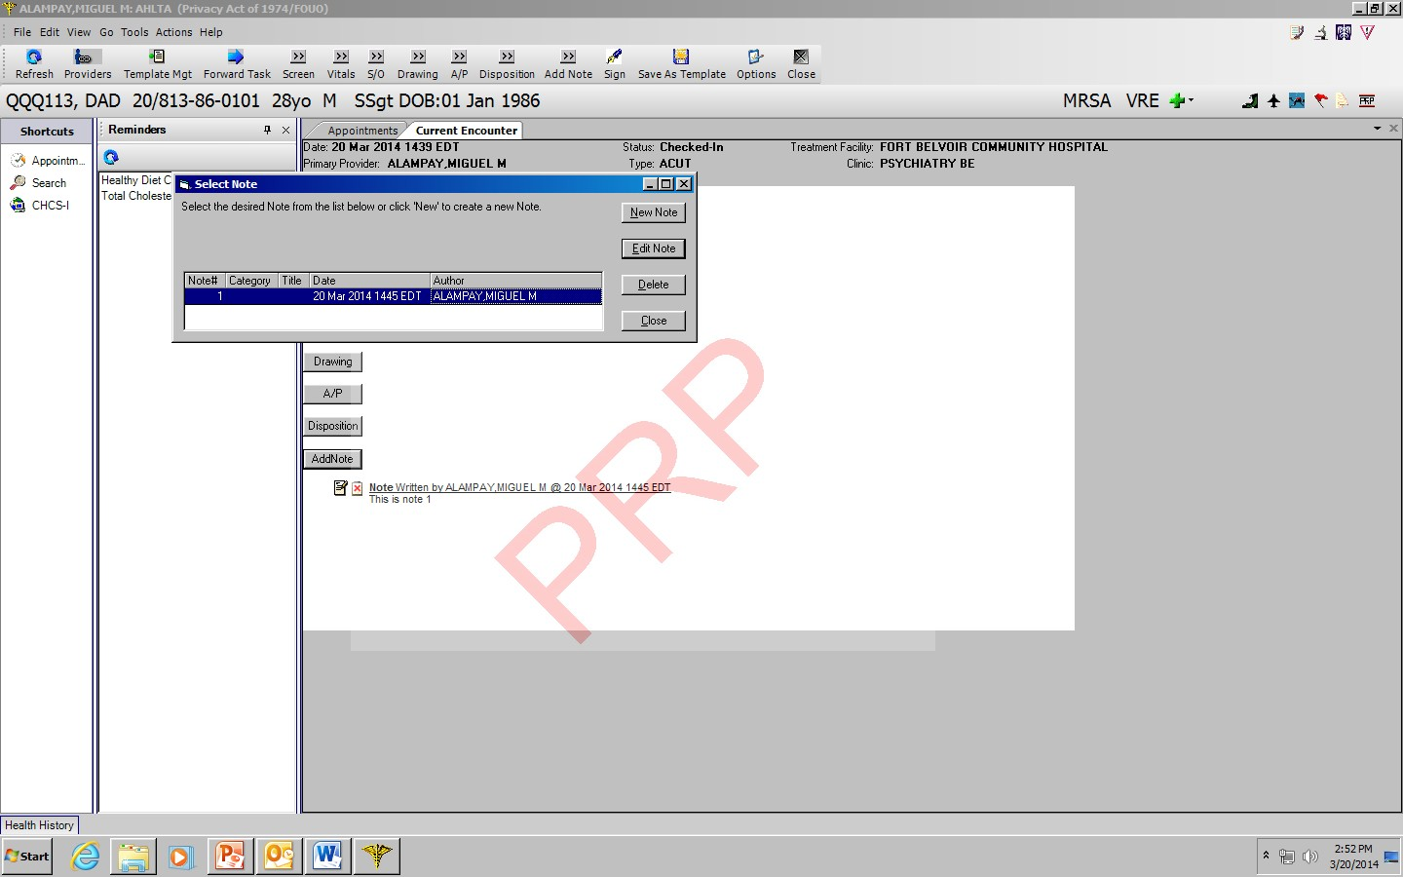

Step 6: After putting your text in, you have three more jobs: A/P (red circle), Disposition (blue circle), and “Sign”
(yellow circle):
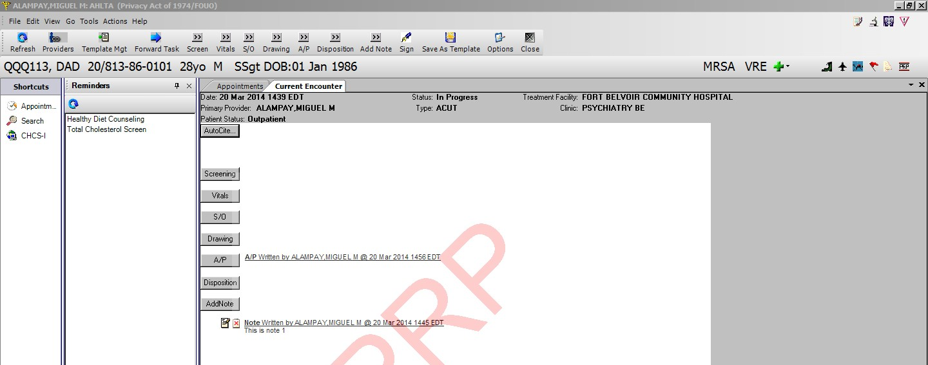
Step 7: When you click “A/P” this will open up. Type in your diagnosis in the “Search” section, find it and double
click. It will populate as you see below. You then click on the “Procedure” tab.

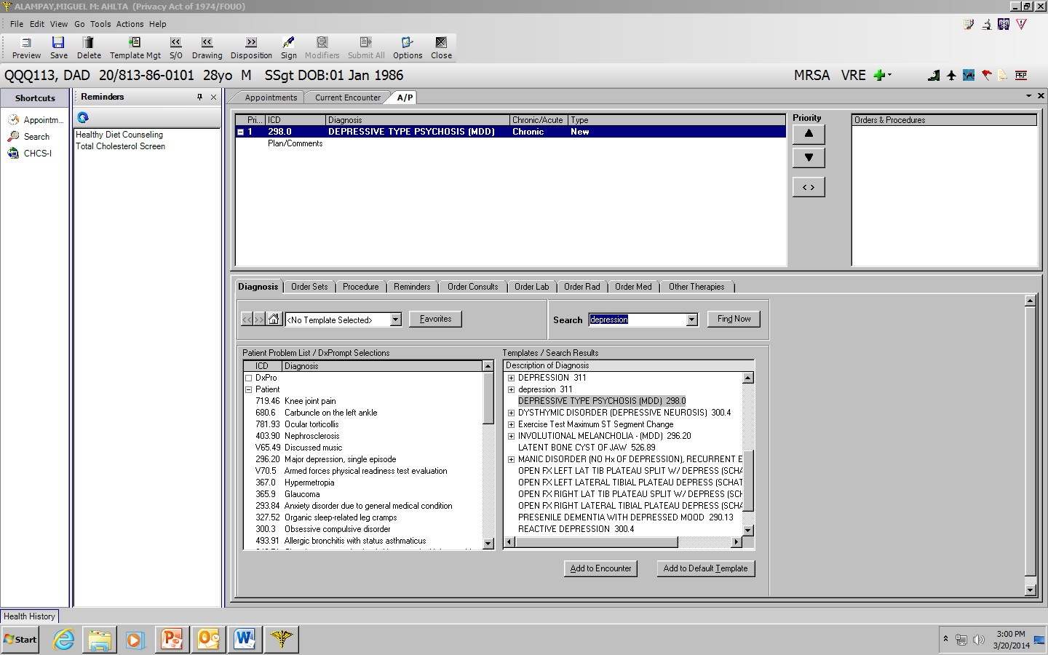

Step 8: Under procedures type in “Comprehensive Psychiatric” and something along the lines of “Psychiatric Evaluation Comprehensive Examination” – CPT code “90792” will populate, click “Add to Encounter” and it will pend to the Diagnosis you just put in.
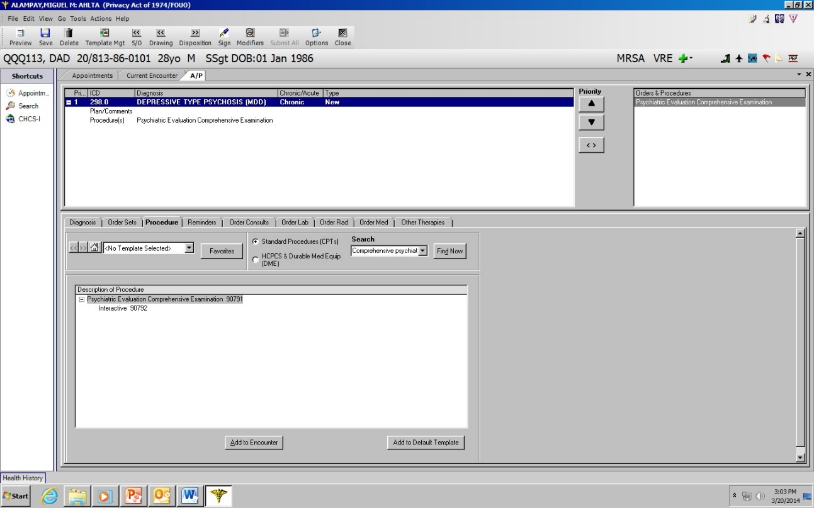

Step 9: If the patient isn’t plugged into behavioral health, click “Order Consult” and fill in appropriately for consults to behavioral health, Paste your Impression/Assessment into the “Reason for Request.” If the patient needs a consult for Inpatient Admission to an outside facility, you would also enter that here. See the section on Send Outs to Civilian Facilities for If the patient needs medication, you cans put that in by clicking the “Order Med” tab.
Inpatient Network Admission Consult Orders are necessary any time you send a patient for an inpatient stay at a non-military facility. This goes for adults and children sent out from the ED, as well as for patients sent from 7W to outside facilities (e.g.; substance rehabilitation, residential PTSD facilities like Freedom Care), and for Veterans Administration Hospitals. This is how Tricare knows the indication for paying the non-DoD entity.

When sending a patient to a private inpatient facility – you must make a consult order. This can be done as part of your AHLTA note – see the “A/P” steps of making an AHLTA note. In the text box of your consult order, you must include the following:
  - Make sure the consult is for: INPATIENT ADMISSION NET BE
  - Diagnosis
  - Name and location of facility to include name and phone number of accepting provider
  - Tax ID number – obtain this from the POC at the facility who accepts the patient.
  - Date service begins (should be the date the patient goes to that facility)
  - Information about a case manager or POC who will be coordinating the return care at WRNMMC
  - What is the outpatient follow-up plan-if it’s back to your clinic, please indicate that. If it’s somewhere
else or you want the treating facility to decide. Please indicate that
  - If there is an outpatient provider of record please provide contact information.
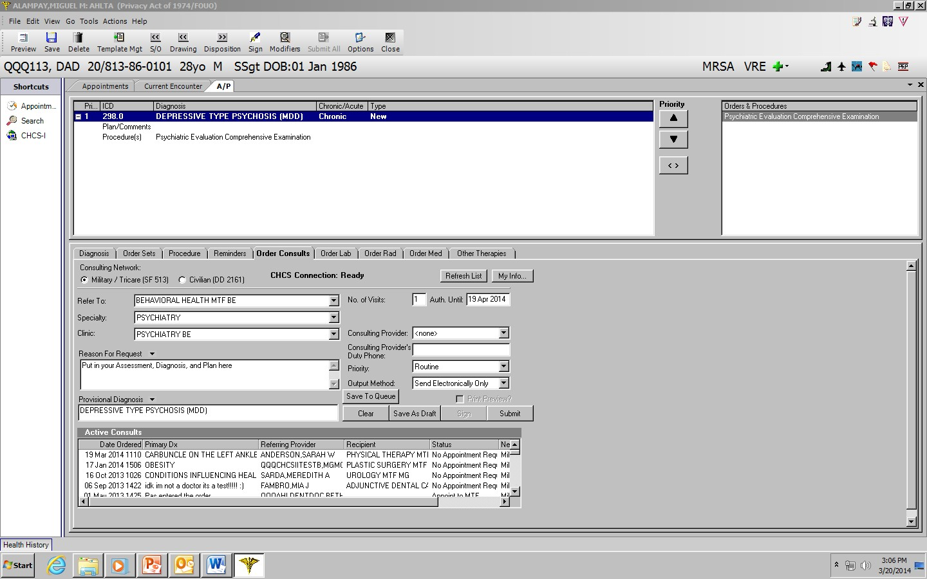

Step 10: Disposition: 1) Fill in the follow-up plan for this patient (black circle); 2) Click All Items Discussed (red circle); 3) Check “50% time spent counseling or coordinating care” (blue circle); then close by clicking the “X” or “Sign” (yellow circles) 4) Change “patient status” to “new patient” and “service type” to “Other E&M” (purple circle)
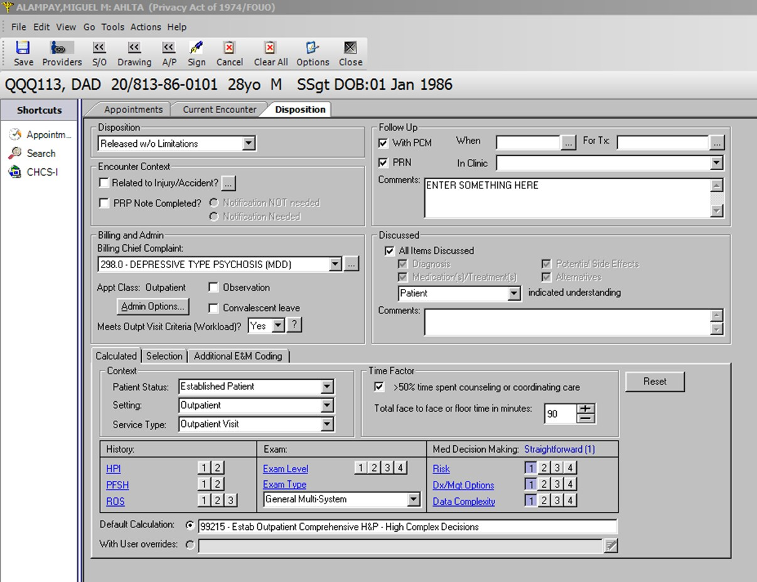
Step 11: SIGN: 1) When you click “sign” the “Sign Encounter” (red box) will come up; 2) Click “cosigner required” and “sensitive” (this creates the privacy *****) ; 3)Then “Search” for your attending which will bring up the “Search” window (Blue box):
You enter in your AHLTA password then “Sign” You are done!

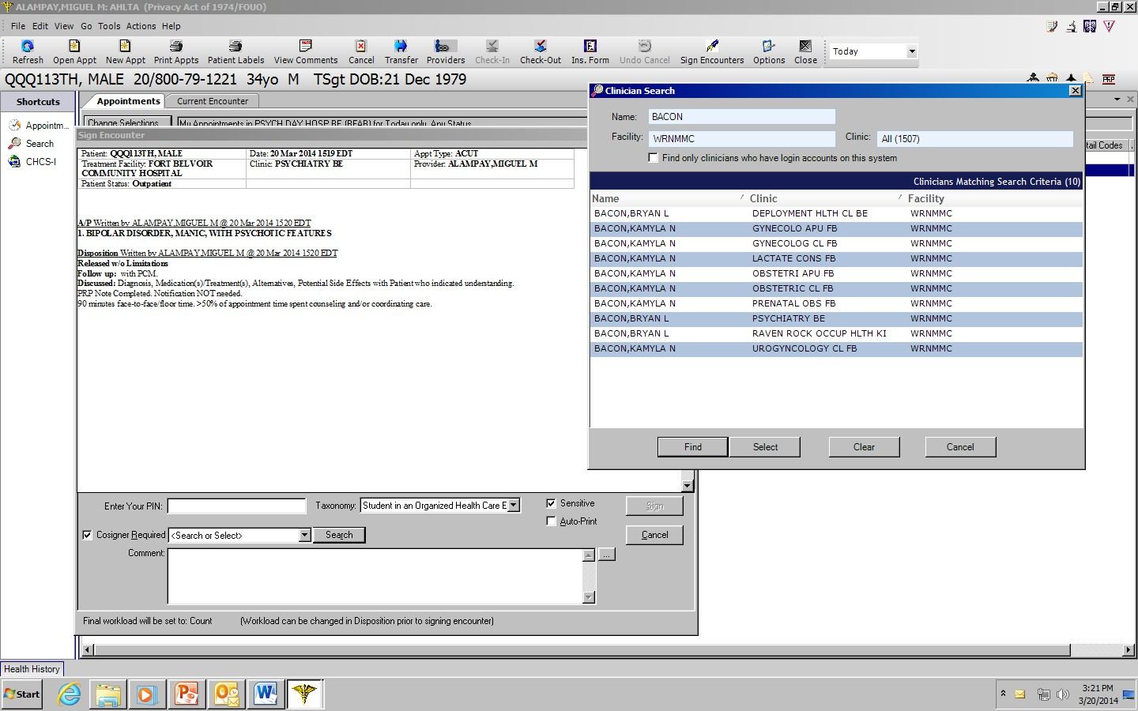

How to Make a Telephone Consult (T-CON)
T-Cons are made in a way similar to AHLTA notes. The main difference is that instead of creating the encounter under the “Appointments” tab you do so by clicking “Telephone Consults” (red) in the Folder List bar, then selecting “New Telcon” (black). You then enter the text of your T-Con into the “Note” text box (blue).
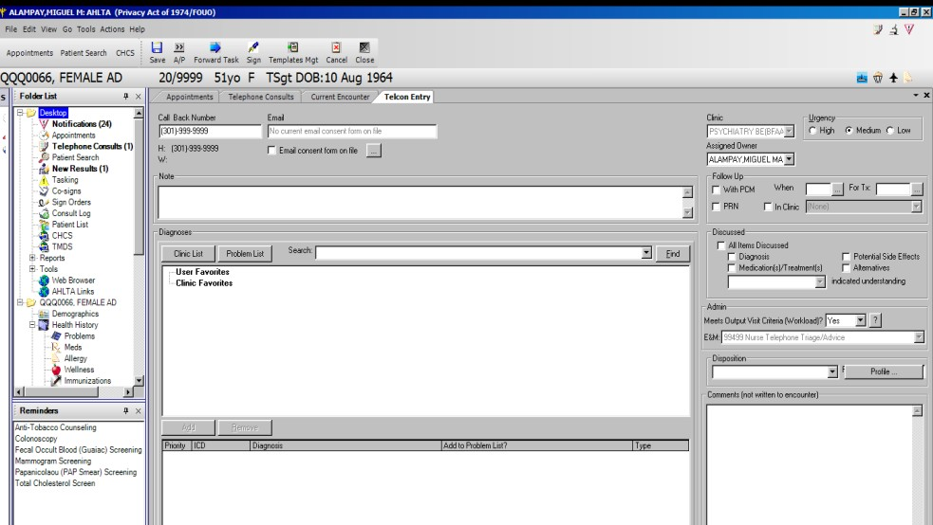
Alternatively, you can click on the “Current Encounter” tab (purple) and write your T-Con through the “Note” box similar to a regular AHLTA Note.
