Chapter 8: Restraints and Elopements

Overview:
Agitated patients are a qualitatively unique aspect of psychiatric practice. A guiding rule should always be to balance the principle of using the least restrictive means possible to protect patient autonomy and dignity with the need to protect all the patients, staff, and bystanders. Restraints, whether chemical or physical, should be seen as last resort options; but options nonetheless. Prior to the use of restraints, staff should attempt de-escalation. Patient elopements place a similar acute stress on PODs. In both situations, PODs must always remember to remain calm and follow established procedures. The following provides guidance and reference to hospital policy – as communication with nursing and hospital leadership are essential components to resolving these issues.
De-Escalation:
If staff members are paying close attention they can usually tell when a patient is beginning to escalate. Quite often, individual attention can de-escalate the situation and prevent physical confrontation.
Do:
- Help patient retain their self-respect by showing that you understand their concern
- Ask how you can help
- Validate what you observe
- Listen carefully, and watch for non-verbal signals
- Help patients express their anger by eliciting the real issues
- Use reality orientation
- Help patients understand their behavior
- Remind patients of the consequences of inappropriate behavior
- Clear other patients and family members from the area Don’t:
- Promise more than you can actually deliver;
- Imply that patient will be punished for their anger

Code Grey is the last-resort code for violent or combative patient with or without weapons. Contact security by calling 777 or (301) 295-1246. Notify them of the violent or combative situation, location, and any other information requested by the security representative. If possible move visitors, patients, and other personnel to a safe location.
Summary of Restraint Policies for Adults
Restraints are a last resort after multiple other techniques at calming a patient have been tried such as time out, increased supervision, medication to treat symptoms, activities, etc. ALL RESTRAINTS REQUIRE RESTRAINT NOTE. When restraints are implemented, the patient and/or family members should beeducated as to why restraints were initiated and what behavior is expected from the patient so the restraints can be discontinued. Only a LIP can order restraints. Restraints can be initiated by an RN or Licensed Independent Practitioner (LIP…read this as a PGY2 or higher). A RN can terminate/end restraints, if reinstated, original time restriction holds (e.g. restraint is started at 1200 at 1300 patient is stable and is released. But at 1400 patient had to be restrained again, original order is good until 1600, no matter how many times the patient is released). The restraint policy of WRNMMC is detailed in WRNATMILMEDCEN ADMINISTRATION INSTRUCTION 6055.09. Although this instructions refers to restraints and seclusions, the policy at WRNMMC is to not use

seclusion. As a result, only the sections of the instruction referring to restraints are relevant: The behavioral health restraint policy itself is effectively as follows:
Definitions
  - Restraint. Any method of restricting an individual's freedom of movement, physical activity, or normal access to his or her body that (1) is not a usual and customary part of a medical diagnostic or treatment procedure to which the individual or his or her legal representative has consented, (2) is not indicated to treat the individual’s medical condition or symptoms, or (3) does not promote the individual’s independent functioning.

Two Types of Restraints (differentiated by situation, not treatment setting):
- The general hospital standards for restraint apply to any use of restraint in situations where the patient demonstrates behavior that interferes with medical healing, such as pulling at tubes, lines, equipment, or dressings, or if the patient is unable to follow instructions and/or comply with activity restrictions, resulting in interference with medical healing. See full instruction for the hospital policy on medical surgical restraints.

- The behavioral healthcare standards for restraint apply to restraints used to protect the patient against injury to self or others because of an emotional or behavioral disorder. In circumstances in which the reason for disruptive or aggressive behavior is unclear, the more restrictive behavioral healthcare standards should be applied.

Restraint in Behavioral Health Care Settings.
- Assessment. The decision to use a restraint is not driven by diagnosis, but by a comprehensive individual patient assessment. The initial assessment is crucial in minimizing the use of restraint.
  - Perform a physical assessment to identify medical problems that may be causing behavior changes in the patient. For example, hypoglycemia, hypoxia, electrolyte imbalances, drug interactions, temperature elevations, and drug side effects may cause confusion, agitation, and combative behaviors.
  - Consider techniques, methods, or tools that would help the patient control his or her behavior. When appropriate, the patient and/or family shall assist in the identification of such techniques.
  - Identify pre-existing medical conditions, physical disabilities, or limitations that would place the patient at greater risk during restraint.
  - Consider any history of sexual or physical abuse that would place the patient at greater psychological risk during
restraint.
- Clinical Justification. The use of restraints for behavioral healthcare purposes is limited to clinically justified situations. Utilize the preventive strategies and alternatives listed below, as appropriate, as these efforts may prevent the need to progress to restraints:
  - Identify the root causes for the patient's behavior.
  - Provide personal space.
  - Use verbal intervention and verbal de-escalation.
  - Remove any patients or visitors from the immediate area for safety.
  - Interact one on one.
  - Reduce stimulation.
  - Encourage physical exercise.
  - Provide distracting activities or games.
  - Offer reading materials.
  - Dispense PRN medications.
  - Encourage relaxation techniques.
- Restraint Initiation Orders. LIP (PGY2 or above) or RN may initiate a behavioral health restraint if all other measures have been exhausted and the patient’s behavior still presents an immediate danger/threat to self or others. The LIP shall:
  - Review with staff the physical and psychological status of the patient.
  - Determine whether restraint should be continued.
  - Supply staff with guidance in identifying ways to help the patient regain control in order for restraint to be discontinued.
  - Educate the patient as to why they were placed in restraint and what is required to remove the restraint.
  - Enter a written order for restraint using standard electronic order set, “Restraints for Behavioral Health” unless otherwise clinically indicated. All restraint orders are time-limited to:
    - Four hours for adults 18 years of age and older.

    - Two hours for children 9-17 years of age.
    - One hour for children under 9 years of age.
  - Initial Evaluation. Upon restraint initiation, the LIP shall complete and document an in-person evaluation of the patient within:
    - Four hours for patients 18 years and older.
    - Two hours for patients 9 to 17 years of age.
    - One hour for patients under 9 years of age.
  - Documentation. Document each episode of restraint and its clinical justification in the “WRNMMC Restraint Note”. Section I of the note is completed by a RN and Section IIby the provider. A clinical note (nursing) or progress note (provider) may be used in addition to this note if needed. The clinical record should reflect the following documentation:
    - Circumstances that led to the use of restraint.
    - Consideration or failure of non-physical interventions.
    - Rationale for the type of physical intervention selected.
    - Notification of the patient's family, when appropriate.
    - Behavior criteria for discontinuation of restraints.
    - Each in-person evaluation or reevaluation of the patient.
    - Assistance provided to the patient to help him or her meet the criteria for discontinuation of restraints.
    - The provision of continuous monitoring.
    - Any injuries that are sustained and treatment received for these injuries.
- Monitoring and Reevaluation. A trained staff member must continuously monitor the patient through in-person observation in order to ensure the patient's safety. The RN must complete Section I and the provider complete Section II of the “WRNMMC Restraint Note.”
  - An appropriately trained staff member must perform assessments at the initiation of restraint and every 15 minutes thereafter. Nursing staff will document this in the EMR’s “Vitals” Flowsheet by click on “Restraints”, right click “Add Row”, and then select “Behavioral Restraints” to populate items. If a paper check sheet is being used, the sheet will be labeled with patients’ identification label, and placed in patients’ charts. An annotation will also be made in the Vital Sign screen indicating that a paper check sheet is used to document every 15 minute assessment. The every 15 minute assessment may include but is not limited to:
    - Signs of any injury associated with the application of restraint.
    - Nutrition/hydration.
    - Circulation and range of motion in the extremities.
    - Vital signs every hour.
    - Hygiene and elimination needs.
    - Physical and psychological status and comfort.
    - Readiness for discontinuation of restraint.
  - The staff must also offer the following when appropriate:
    - Bathing and oral hygiene, at least once during a 24 hour period.
    - Meals, at regularly scheduled hours and under supervision.
  - Restraints are time-limited by age as above ((5) (a), (5) (b) and (5) (c)). If there is a continued need for restraints and the time limit has expired; a RN and LIP will reevaluate the patient in person to document in “WRNMMC Restraint Note ” for the new episode. The LIP will initiate a new order.
- Restraint Release. Once the patient meets behavioral criteria for release of restraints, the RN or LIP will document this release in the “WRNMMC Restraint Note .” The LIP will discontinue the order.
- Debriefing. It is important to debrief every episode of restraint, in order to reduce the recurrent or inappropriate use of restraint in the future. Hold the debriefing with the patient and, if appropriate, the patient's family, along with the staff involved in the episode. The debriefing should occur as soon as possible, but no longer than 24 hours after the episode. Document the debrief in the “WRNMMC
Restraint Note ”. The debriefing is used to:
  - Identify what led to the incident and what could have been handled differently.
  - Ascertain that the patient's physical well-being, psychological comfort, and right to privacy were addressed.
  - Counsel patient for any physical or psychological trauma resulting from the episode.
  - When indicated, modify the patient's treatment plan.

How to Order Restraints:
Step 1: Go to the order set options by clicking the double-pill icon (red circle); and highlight “Restraints for Behavioral Health” (blue circle) – note that the Medical-Surgical option is just below. Then “OK.”
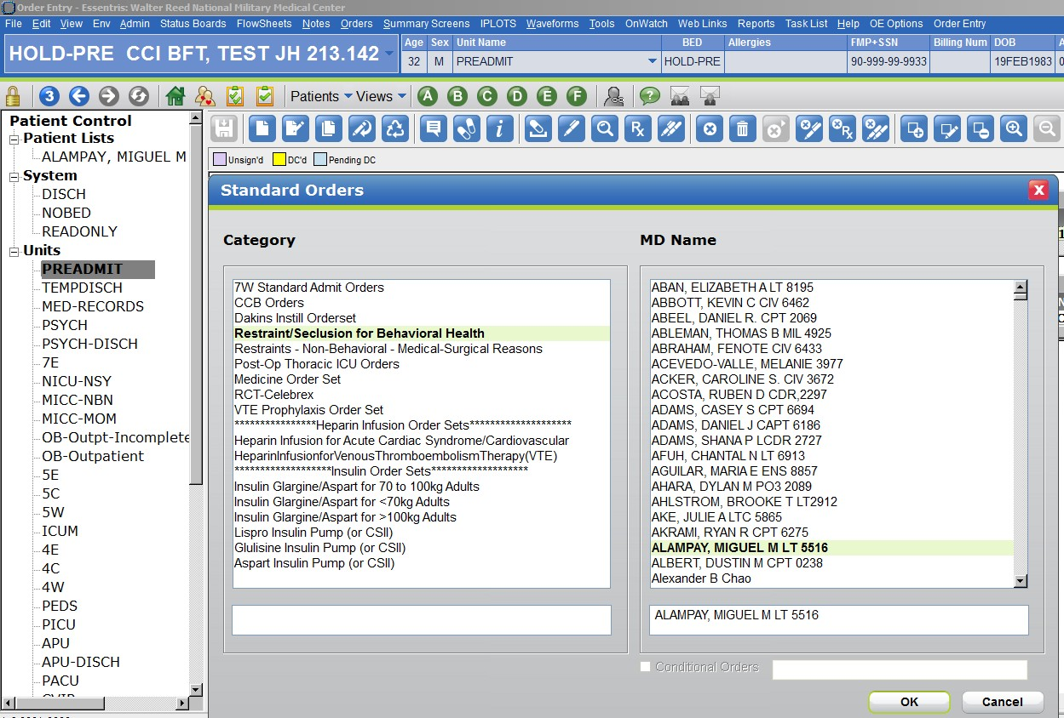
Step 2: Select the Appropriate restraint orders. Hold down the “Ctrl” key to select multiple orders simultaneously. Note that there are 5 orders that need to ALWAYS be selected – brochure to patient/family, restraint note, periodic assessments, nurse may release, specified behavior for release. These are the highlighted orders in the image below. Note that you must actually specify a behavior for release in the comments for the last order (red circle). You can do this by right clicking over the order and left-clicking on “Edit Order.” In addition to those 5 orders, you must choose between two of the “time limits” based on age (blue box). As long as 7W is an adult ward you will only use the 18 and over 4 hour limit). In the event you recommend behavioral restraints in a consult on the pediatric ward, it will be the primary team that orders the restraints (and you should make sure the Staff on Call is aware that you are recommending restraints). You must also choose one of the two “Justification:” options (yellow box).

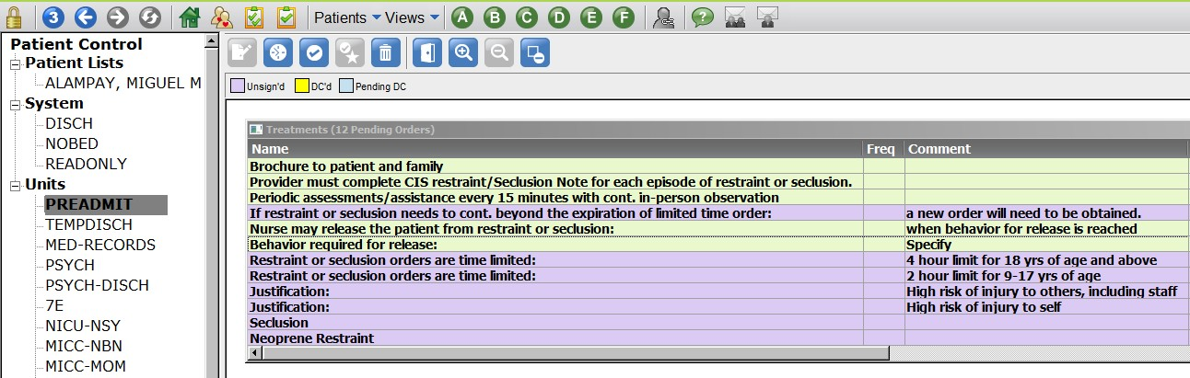

Step 3: As with other order sets (e.g. Admissions), once you have all the orders you would like selected click the
“check” box (black circle), then the “Exit Door” (purple circle).

Step 4: Notify Staff on Call if you haven’t already done so.
Elopement:
The hospital code for an elopement or lost person is Code Purple – as described in WRNMMC-AI6490.01. If a patient under suicidal ideation care elopes, the ED Staff, clinic, or hospital unit will initiate a Code Purple status by contacting WRNMMC security. Upon elopement of a potentially suicidal patient from the ED or Hospital unit, the (OOD) will also be immediately notified.

The OOD will be responsible for notification of the CDO, WRNMMC Security, the NOD, and the Psychiatry watch (including resident and attending). The local police department will be notified by WRNMMC Security. For active duty service members, their chain of command will also need to be notified. See WRNMMC-AI 6490.01 found in the Chapter on Emergency Evaluation.

