Appendix D: Mindful Language Toolkit

Important Questions to Consider
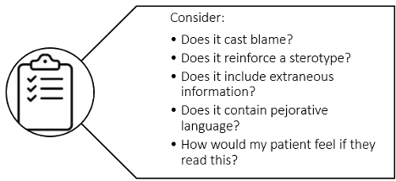
Author Owned

Attitudes that communicate bias or neutrality in medical documentation:
Stigmatizing | Neutral
Patient is abusing medical resources | Patient is here to seek help
Using labels and stereotypes to communicate patient conditions or contexts (e.g.: “difficult”; “drug-seeking”) | Objective, individualized descriptions of the patient’s experiences and actions promote patients’ best interests among providers
Documentation discounts patient’s identity, uses assumed gender data or avoids topic altogether | Documentation reflects patient’s presentation of self
Patient is solely responsible for their medical problems | Patient’s condition is multifactorial, and it is important to dissect its root causes beyond individual responsibility
Another provider will have more time to document with less bias than me | Biases reflected in medical documentation/language perpetuate stigma for each subsequent provider

General tips

Avoid | Use
Making the patient their disease (e.g. “she is bipolar”; “sickler”; “substance abuser”) | Phrases like “He has X disorder”
Using unnecessary quotations | Patient’s exact words judiciously
Words that cast doubt on a patient's experience (i.e.: patient claims, believes…) | Neutral language that accurately relays history (i.e.: patient reports, states…)
Words which imply decreased agency for patients with disabilities (wheelchair bound versus wheelchair user) | Patients’ own descriptions of their disabilities
Be aware of words that might be perceived as racist, sexist, or stereotyped  “That’s retarded”  “She’s hysterical” | Patient’s subjective experience of their illness
Extraneous details that do not impact the condition for which the patient is presenting (e.g. incarceration history, race) | Using pertinent details only
Writing in a way that would be problematic for a patient or family member to read | Writing transparently, clearly
Using pejorative, dated terms for disease (“pseudoseizure,” “vegetable,” “retarded”) | Appropriate disease terminology (“PNES,” “minimally conscious state,” “intellectual disability”)

Special considerations for specific content areas
Avoid | Use
Substance use:  “Substance abuser, opiate addict, alcoholic”  Test was “dirty” or “clean” | “Person with substance, opioid, or alcohol use disorder”; “period of abstinence”  “Your test shows X”
Mental health:  “S/he’s bipolar”; “crazy”; “borderline”  “Committed suicide”; “successful suicide” | “SF has a known diagnosis of bipolar I disorder”  “Died by suicide”
Disabilities:  “Wheelchair-bound”  “Deaf and dumb” | “Wheelchair user”  “Hearing- and speech-impaired”
Social history:  “Homeless person”  “Ex-convict” | “Patient experiencing homelessness” or “unhoused person”—can specify chronic or acute  “Person with a history of incarceration”
Gender:  Assuming or not asking about gender identity, pronouns, etc. | When relevant to care, note sex on birth certificate, gender identity, treatments or surgeries, and pronouns

